1.0 Introduction
In system analysis, decision tables and decision trees are essential tools used to model complex logic in a simplified and structured form. They help analysts visualize conditions and corresponding actions clearly. This assignment focuses on analyzing a payroll system using decision tables and decision trees to manage two employee types—salaried and hourly while handling conditions such as overtime and absences. The main goal is to demonstrate how these tools assist in accurate and logical decision-making in real-life business systems.
1.1 Statement of the problem
Many payroll systems face challenges in managing diverse employee categories and complex payment rules, which can lead to errors, inconsistencies, and inefficiencies. In the given scenario, the payroll system must distinguish between salaried and hourly employees and apply specific logic to handle overtime and absences based on hours worked.
Curiosity arises from understanding how logical decision tools like decision tables and trees can simplify complex business logic, reduce confusion, and help in designing more robust and error-free payroll systems. This assignment seeks to explore how these techniques contribute to effective system design.
1.2 Objectives of the study
•To examine how decision tables simplify payroll logic.
•To explore the use of decision trees in representing payroll decision-making. •To reveal the differences in logic handling for salaried and hourly employees. •To find out how systems can manage overtime and absence conditions logically.
•To understand how decision modeling improves payroll system accuracy.
1.3 Significance of the study
This study benefits system analysts, software developers, and HR managers involved in payroll management. By providing a clear representation of payroll logic, the decision table and tree enhance understanding and communication among stakeholders. It also serves as a guideline for implementing logic in

payroll software, ensuring transparency, accuracy, and efficient decision-making.
1.4 Limitation of the study
•The study is based on a simplified payroll scenario.
•It assumes fixed rules and does not account for all real-world exceptions. •Only two employee types are considered: salaried and hourly.
•The decision logic does not include tax calculations or benefits.
•The scope does not include implementation in code.
2.0 Methodology and data collection
This study adopts a descriptive and analytical approach. First, the payroll logic was extracted from the given narrative. Then, using system analysis techniques, the logic was broken down into conditions and actions to form a decision table. A corresponding decision tree was also designed to represent the logic visually. These tools were then interpreted to show how decisions are derived based on input data.
Decision Table Representation
Rule |  | Emp | Hou | Abs | Ove | Explan
 |  | loye | rs | ence | rtim | ation
 |  | e | wor | > 40 | e >
 |  | type | ked |  | 40
 | 1 | Salar | - | No | No | Gets
 |  | ied |  |  |  | basic
salary
only.
No
hourly
wage or
reports.
2 | Hour | <40 | Yes | No | Hourly
 | ly |  |  |  | wage.

Absenc
e report
generat
ed.
3 | Hour | < | N | N | Hourly
 | ly | 4 | o | o | wage
 |  | 0 |  |  | only.
No
absence
or
overtim
e report.
4 | Hour | >40 | No | Yes | Hourly
 | ly |  |  |  | wage.
Overtim
e report
generat
ed.
5 | Hour | >40 | Yes | Yes | Hourly
ly
3.0 Result and discussion
The above decision table suggests that salaried employees always receive a basic salary regardless of hours worked, while hourly employees are compensated based on the number of hours. If an hourly employee works less than 40 hours, an absence report is triggered, signaling underperformance. Conversely, if the hours exceed 40, the system triggers an overtime calculation, compensating the worker accordingly. This logical mapping shows how decision tables clearly define multiple outcomes based on different input combinations.
The corresponding decision tree (see below) further simplifies understanding by branching out based on employee type and hours worked. This visual method is highly effective for both technical and non-technical stakeholders to grasp the flow of decisions in the payroll system.ss

Decision Tree Representation
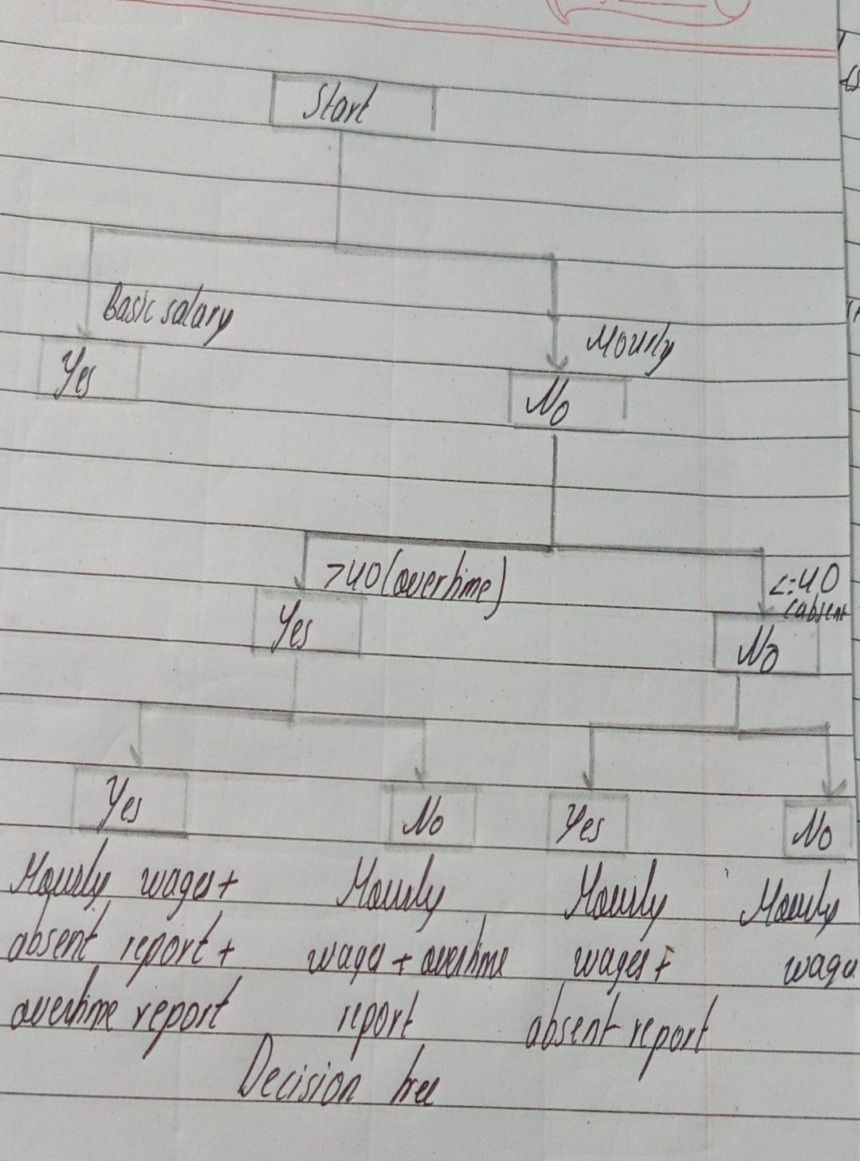
4.0 Conclusion
The result and discussion highlight how decision tables and trees help organize complex logic in system analysis. The payroll system's logic, though simple, involves different outcomes depending on employee type and working hours. By using these tools, developers can create error-free and clearly structured systems that ensure fair payroll processing for all types of employees. It is recommended that more conditions such as bonuses, leaves, and tax deductions be included in future models for better real-world applicability. These tools can be incorporated into payroll software prototypes or even

converted into program logic using languages like Python or Java for implementation. More advanced decision tools like rule engines can also be explored for scalability.
5.0 References
1.Kendall, K. E., & Kendall, J. E. (2010). Systems Analysis and Design (8th ed.). Pearson Education.
2.Awad, E. M. (2004). Systems Analysis and Design. Galgotia Publications. 3.Satzinger, J. W., Jackson, R. B., & Burd, S. D. (2012). Systems Analysis and Design in a Changing World. Cengage Learning.

